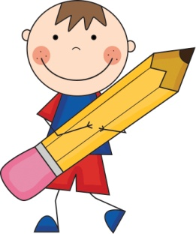
First Grade Supply List
2013-2014
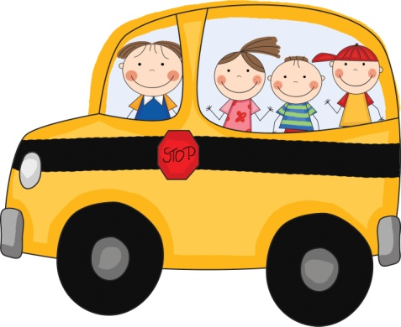
- 2 boxes of 12 count pencils (sharpened)
- 2 erasers
- 24 pack of Crayola crayons
- 4 glue sticks
- Ruler- No rubber rulers
- Safety scissors
- 8 pack of Markers
- Watercolors
- 2 folders
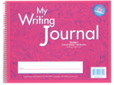
- 2 Zaner Bloser Writing Journals
Can be found at Teacher Supplies in Buena Park or CM School Supply (Long Beach or Anaheim)

- 1 Mead Primary Writing Journal
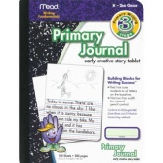
  - Can be found at Walmart or Target

- 4 pack of dry erase markers
- Set of addition and subtraction flash cards
- 1 USB flash drive
- 1 set of ear buds or headphones
- 2 large boxes of tissues
- 2 reams of white paper
- 1 large container of Clorox wipes
- Boys only-Pump bottle of hand sanitizer
- Girls only- 1 package of baby wipes
- Change of Clothes in a Ziploc bag clearly labeled with student’s name
- 1 used oversized shirt to be used when painting- Please label it with student’s name
Be sure to mark student’s name on all uniform items (jackets, vests, lunch boxes, backpacks, etc.)
Please bring all supplies to school on the FIRST DAY of school. School begins on August 15th. The first week of school is early dismissal at 12:30. Our first full day of instruction begins August 19th from 7:40 a.m.-3:00. All Fridays are 12:30 dismissal

